

Phone: 1234567890
W. App: 1234567890
Email: labtestsguide@gmail.com
Website: www.labtestsguide.com

Address: This is the address of Lab, State Lab, Collection Center or Specimin Pick Up Point.
Pt. Name | Lab Tests Guide |  | Registered On | January 1, 2026 10:33:28 PM
Age/Sex | 34 Y / Male |  | Reported on | January 1, 2026 10:33:28 PM
Contact No | +1234567890 |  | Consultant | Lab Tests Guide
Specimen | Amniotic Fluid |  | Reference | LTG Reference
Patient ID: 260101-234-234
Patient ID: 260101-234-2348
Registered By: LTG
Amniotic Fluid Analysis Test
Test Parameter | Reference Range | Unit | Test Result | Flag
Lecithin/Sphingomyelin (L/S) Ratio | ≥ 2.0 | Ratio | 2.2 | N
Alpha-fetoprotein (AFP) | 0.5-2.5 | MOM | 1.8 | N
Glucose | 15 – 40 | Mg/dl | 36 | N
Bilirubin (ΔOD 450) | Zone-specific | Absorbance | Low zone | N
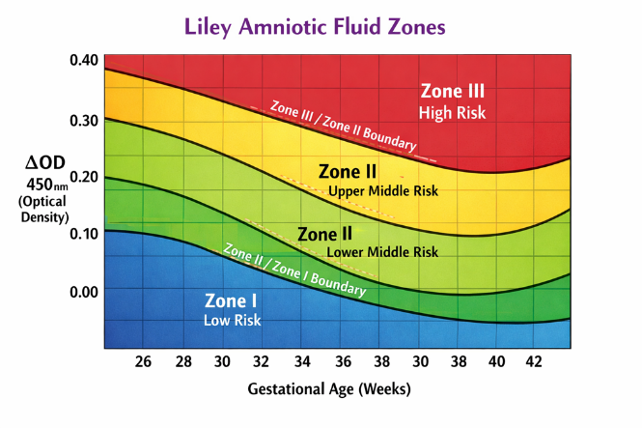
Collection Method | Ultrasound-guided Amniocentesis
Sample Volume | 14 ml

Clinical Significance:
- L/S ratio indicates adequate fetal lung maturity.
- AFP level is within normal range; no evidence of neural tube defect.
- Bilirubin level suggests no significant fetal hemolysis.
- Overall findings are within normal limits for gestational age.

Comments:
- This test checks the baby’s health by analyzing the fluid around the baby.
- The results suggest normal development and mature lungs at this stage of pregnancy.



-------------- End Report ----------------
Note: This demo test report is for educational purposes only and not intended for legal or clinical use.
Technologist Name | Pathologist 1 Name | Pathologist 2 Name | Pathologist 3 Name
Biochemist  Education etc. | Hematologist  Education etc. | Microbiologist  Education etc. | Histopathologist  Education etc.

